Step 1: Install Required Software (Download Step)
Before running anything, install these:

1. Install Java (Required for Kafka)
- Download JDK 8 or 11
- Verify:
Command:
java –version
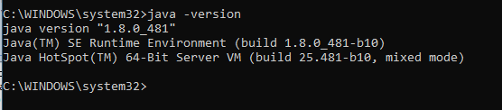

2. Download Apache Kafka
- Download from: https://kafka.apache.org/downloads
- Extract to:
Command: D:\kafka

3. Install MongoDB Compass
- Download: https://www.mongodb.com/try/download/community
- Start service after install

🔹 4. Install Python Libraries
Go to your project folder:
cd D:\kafka_app
Install dependencies:
pip install pyqt5 kafka-python pymongo scikit-learn python-dotenv google-generativeai
📌 [Insert Screenshot: pip install output here]

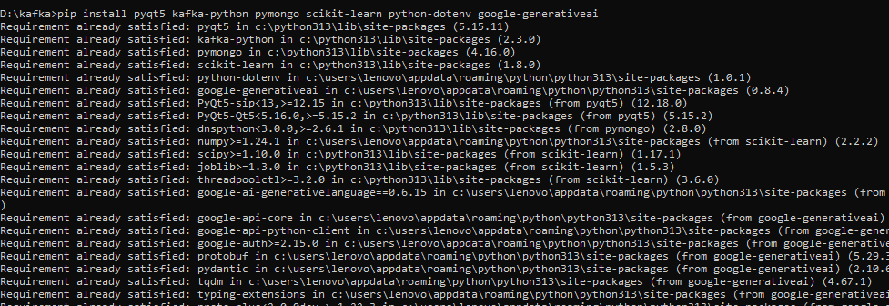

⚙️ Step 1: Start Zookeeper
cd D:\kafka
.\bin\windows\zookeeper-server-start.bat .\config\zookeeper.properties
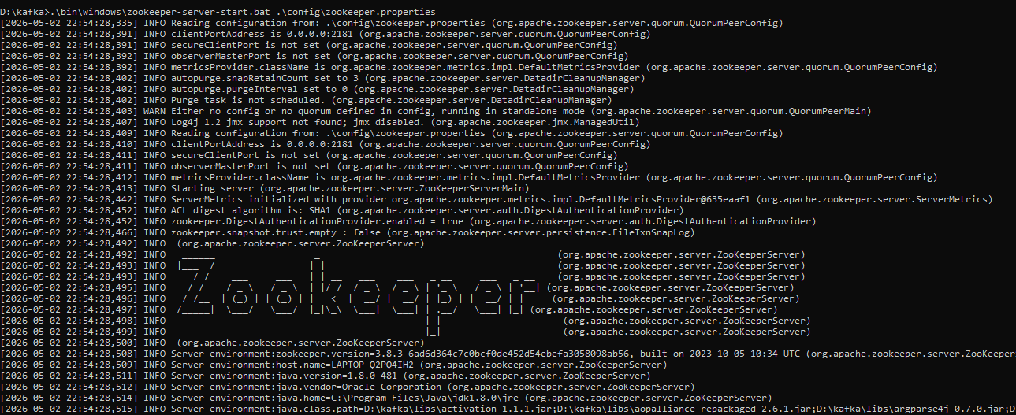

Step 2: Start Kafka Server
cd D:\kafka
.\bin\windows\kafka-server-start.bat .\config\server.properties
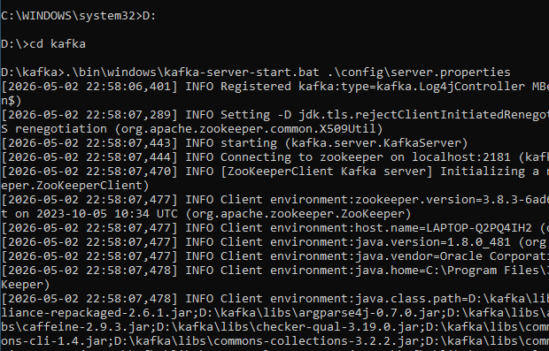

Step 3: Create Topics
.\bin\windows\kafka-topics.bat --create --topic chat-room --bootstrap-server localhost:9092 --partitions 1 --replication-factor 1
.\bin\windows\kafka-topics.bat --create --topic tech-talk --bootstrap-server localhost:9092 --partitions 1 --replication-factor 1
.\bin\windows\kafka-topics.bat --create --topic random --bootstrap-server localhost:9092 --partitions 1 --replication-factor 1
.\bin\windows\kafka-topics.bat --create --topic announcements --bootstrap-server localhost:9092 --partitions 1 --replication-factor 1
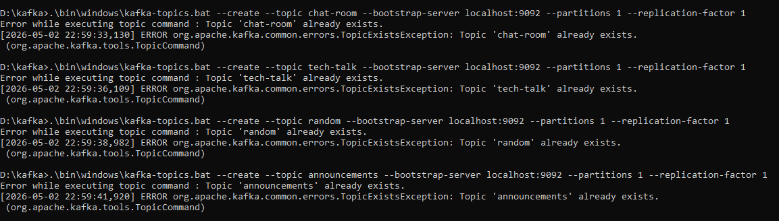

⚙️ Step 4: Start MongoDB
Connect mongodb localhost in mongodb compass

Step 5: Run Application
cd D:\kafka_app
python main.py
